Theresa Diehl Physical Climatology Literature Review 7/28/2026

Anthropogenic Forcing of Global Warming:
Its Effects on the West Antarctic Ice Sheet from Ocean-Ice Shelf Interaction

1. Abstract
Global warming is a central issue to the debate on abrupt climate change. The extent to which humans have induced anthropogenic forcing of global warming is a critical part of this issue, as is the impact of global warming on the Earth’s ice sheets. Some studies, of international recognition, have shown that global temperatures are on the rise and are higher than any other time in the last 1000 years, though some of these findings are contested as being based on flawed data and methodology (McKitrick, 2003). The magnitude of the temperature increase in the last century is of key importance to the discussion of anthropogenic forcing of global warming. Assuming that the human race has induced part of the global warming, one may wish to decide if or how much this anthropogenic forcing will affect future climate change (Hansen, 2005). Evidence from ocean temperatures over the last 40 years points to a distinct anthropogenic signal of warming (Barnett et al., 2005). Ocean temperatures directly affect the West Antarctic Ice Sheet (WAIS), one of the least well-known parts of the world that is often not included in global climate models. The WAIS could completely collapse on scales of 100s of years if perturbed sufficiently by changes in climate, including the oceans (Oppenheimer, 1998). The WAIS is particularly vulnerable to ocean temperature warming because of the discharge rate of the marine ice sheet depends on changes to its ice shelves and coastal areas (Payne et al., 2004; Shepherd et al., 2004). Although scientists are debating the magnitude of anthropogenic forcing, the impacts of the forcing are clear with respect to the WAIS. If anthropogenic forcing of global warming continues, then there is mounting evidence for dramatic thinning and possibly collapse of the WAIS (Payne et al., 2004; Shepherd et al., 2004), yielding massive changes in sea level up to 6m in the next 400-700 years (Oppenheimer, 1998).
2. Anthropogenic Forcing of Global Warming
The Intergovernmental Panel on Climate Change (IPCC) published their 3rd Assessment Report in 2001. This report has come under heavy fire from the scientific community for questionable evidence of global warming and a flawed review processes, especially pertaining to the ‘hockey stick’ diagram of global temperatures over the last 1000 years (Figure 1) (McKitrick, 2003). McKitrick’s (2003) discussion of the Mann et al. (1999) ‘hockey stick’ diagram (hereafter referred to as Fig. 1) is a pointed, critical attempt to refute Mann, et al.’s work. McKitrick states that the IPCC, which is often viewed as giving the penultimate word on climate change to governments around the world, weighted Mann et al.’s work too heavily and that the IPCC review process failed to realize that the diagram is based on faulty data and methodology. This 3rd IPCC report has been used by governments to support the adoption of the Kyoto Protocol.
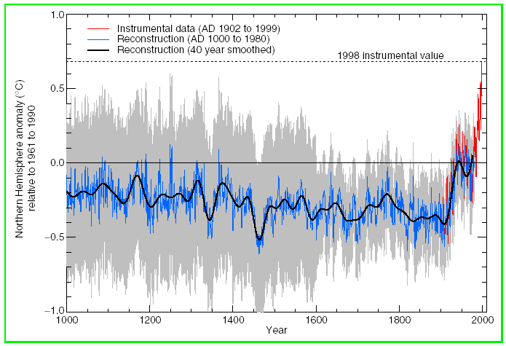
Figure 1: IPCC p. 29 of the 3rd Assessment Report Technical Summary with given caption: “Millennial Northern Hemisphere (NH) temperature reconstruction (blue – tree rings, corals, ice cores, and historical records) and instrumental data (red) from AD 1000 to 1999. Smoother version of NH series (black), and two standard error limits (gray shaded) are shown.” (McKitrick, 2003)

McKitrick reviews the previous IPCC report (1998) to find that the results published there indicate temperatures of the Medieval Warm Period (1000-1400 A.D.) showed much greater temperature increases than those seen with modern temperatures. Borehole data agrees with this assessment. The question then arises of what Mann et al. (1999) included in their analyses to yield such a different pattern to historic temperatures than the 1998 IPCC report. McKitrick is critical of Mann’s reluctance and even refusal to provide codes and data to a third party (McIntyre, an economist interested in the work) and to McKitrick. McIntyre and McKitrick analyzed the provided data and found data errors and omissions. They were also unable to replicate the principal component analysis results of Mann et al. These findings cast doubt as to the accuracy of Fig. 1. Despite little cooperation from Mann and his colleagues, McKitrick and McIntyre managed to closely, but not exactly, replicate Fig. 1. Proxy time series of temperature from bristlecone pine trees on Sheep Mountain, CA are required to produce the shape of Fig. 1. These time series were noted by dendrochronologists and others are being spurious and not being representative of global temperature but Mann, et al. included them in their analyses, extrapolated them back into time, and heavily weighted them. Removal of these few time series results in a permanent loss of the ‘hockey stick’ shape to the temperature curve. This indicates that the results of the Mann et al. methodology are neither stable nor robust and, in fact, very sensitive to the inclusion of a few outlier time series.
McKitrick’s review and rebuttal of Mann et al.’s temperature curve was certainly a scientific process, though it is obvious to the reader that McKitrick is emotionally heated about the issue. Perhaps the emotion that comes through in his writing is because due to frustration about the over-reliance of the world’s governments on the IPCC report, the IPCC’s failure to adequately critique the work included in their report, or McKitrick’s difficulty in working with Mann and his colleagues, all of which McKitrick mentions in his paper. However, despite the obvious emotional charge to the paper, the scientific rebuttal of Fig. 1 appears to be solid work and not undertaken as a personal vendetta against Mann and his colleagues.
The backlash of the scientific community against the temperature ‘hockey stick’ has started to convince scientists of the error in Mann et al’s work but many still support other evidence for anthropogenic forcing of global warming and its impacts on climate. Some compelling evidence for anthropogenic forcing includes the energy imbalance of the Earth, which shows that 1 W/m² more energy is being absorbed than emitted (Hansen, 2005). This fact, along with evidence of surficial melting and accelerated discharge of the Greenland ice sheet, led Hansen (2005) to examine the sources, rates, and impacts of global warming on ice sheets.
Hansen states that the IPCC (2001) scenarios of sea level rise include rapid growth of climate forcing through 2100 resulting in thermal expansion of the oceans and melting of alpine glaciers. The estimate assumes a zero contribution from Greenland and Antarctica to sea level rise. The IPCC report also states that CO₂ and CH₄ are much higher than ever observed over several hundred of thousands years into the past. This evidence points towards anthropogenic forcing of the climate above and beyond the warming due to changes in Earth’s orbital parameters. Hansen forecasts that, though the effects of warming have been slow thus far, they will speed up in the near future. In this prediction, as air temperatures increase, the area of ice sheet surficial melting increases, sea level rises, and more water lubricates the bed of the ice sheets to allow increased ice discharge into the ocean. Hansen’s view of the effects of atmospheric forcing on ice sheets is very realistic but he goes on to point out, appropriately, that the oceans are actually more important in ice sheet forcing. Hansen points out that most of the Earth’s incoming energy goes into the ocean and that increased ice melt will lead to a positive feedback temperature loop for the ice sheets. In this loop, some ice melts, the temperature of the mixed ocean layer decreases, latent heat and sensible heat of the oceans decrease, and the planet loses less heat (increasing the total net absorbed heat flux) thus increasing temperature and inducing more melt. As well, increased air pollution boosts ice melting because a few extra parts per billion of soot on the ice surface changes its albedo by 1%.
Despite the importance of ice sheets to climate, Hansen says that ice sheet models are lacking the robustness needed to simulate reality. The models lack basal lubrication effects and are unable to replicate both Heinrich events and realistic disintegration times as seen for ice sheets in the past. Thus the ice sheets’ response to planetary imbalances and its effects on climate are the least well-constrained of global climate controls. The time for sea surface temperatures to respond to imbalances and even the time for the human race to change its greenhouse emissions are more readily estimated.
Hansen defines a substantial sea level rise as 2m, of which 0.5m comes from thermal expansion of the ocean and melting glaciers and 1.5m comes from melting of the ice sheets. At the end of the last glacial maximum, sea level rose 20m in 400 years. Although the ice was at lower latitudes at that time, a much smaller rise in sea level today could wreak havoc on our society. Hansen concludes that a 1ºC increase in temperature above current average global temperature would constitute “dangerous anthropogenic interference” and that society should keep climate forcings from exceeding an extra 1 W/m² above our current energy imbalance. Scenarios show that a 2ºC increase in temperature above today’s puts us in the danger zone for rapid ice sheet imbalance and disintegration.
Hansen also addresses the fact that society is capable of limiting further warming to safe levels (<1ºC) but that little action is being taken to do so. In fact, he points out that the current acceleration of fossil fuel usage is alarming and that society needs “…strategic planning and strong concerted actions…” to slow down global warming. This is a very strong stance to take in the political area, particularly considering the policies of the US government with respect to global warming. However, he also says that documents such as the IPCC report need to be subjected to the same scrutiny as other scientific papers. This implies that while Hansen believes that society should take immediate steps to curb global warming, he acknowledges that others believe his view is alarmist and that more research is needed to attain solid scientific conclusions on global warming.
Hansen takes a more conversational tone in this paper, which is appropriate because it was published as an editorial essay. His arguments are convincing despite his fact that his expertise lies outside of glaciology. The article is alternately serious and amusing, making it easy to read while also being dense with information. Hansen relies on very few figures and instead talks through his arguments. Some may consider this akin to building a house of cards but the arguments presented are well thought out and solid. Hansen’s paper naturally leads scientists to question whether the oceans are really absorbing most of the observed large energy surplus and whether glaciologists also believe that the response of the Antarctic Ice Sheet will be so critical to climate in the near future.

3. Effect of Anthropogenic Forcing on the West Antarctic Ice Sheet

3.1 Effect of Anthropogenic Forcing on Ocean Temperatures
In fact, Hansen’s supposition that the oceans are absorbing the majority of the Earth’s energy surplus is confirmed by Barnett et al. (2005), who state that ~84% of Earth’s heating in the last 40 years has gone into warming the oceans. Barnett et al. identify a complicated signal of warming in 6 ocean basins of the world, the north and south: Atlantic, Pacific, and Indian Oceans (Figure 2). The signal differs from basin to basin and with depth in each basin, showing that previous studies that examined a world-wide surficial average could not capture the true heterogeneity of the warming signal. Their analyses involved defining a “fingerprint” for each basin, i.e. a mask or specific spatial boundaries. Barnett et al. do not elaborate on how the boundaries are chosen, especially in non-obvious areas such as between north and south portions of the same ocean and in areas where different oceans meet. They also do not consider the Antarctic and Arctic Oceans, presumably due to lack of data in those areas. The ocean temperature is calculated over decadal periods at each level of the ocean, thus identifying the low frequency temporal changes in temperature and not the seasonal or yearly changes.
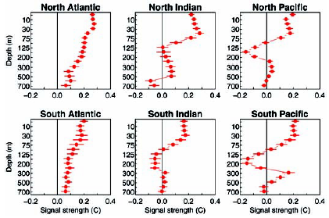
Figure 2: Change of temperature with depth for observations from 1960 to 2000 for 6 ocean basins world-wide (Barnett et al., 2005).

Barnett et al. identify three possible causes for the spatially and vertically heterogeneous warming signals observed: natural, internal ocean-atmosphere forcing; external variability due to
solar or volcanic forcing; and/or unnatural human forcing such as greenhouse gas or sulfate aerosol
emissions. They proceed to examine each cause individually to identify the source or sources of ocean warming. Using the Parallel Climate Model (PCM), developed by other scientists, they performed a control run to obtain model estimates of the ocean temperatures with depth. By running the PCM several times, they estimated the 90% confidence level of the model results (Figure 3). These control runs tested the internal, natural ocean-air variability and the results show that part of the warming signal can be explained this way, but that there are significant deviations between the observed signal and the model results. The observed warming signal is larger than predicted in almost all levels of the 6 basins. The upper 75m of all basins are affected by greater than predicted warming as well as depths to ~250m for both the North and South Atlantic. When external forcing from measured solar and volcanic variability are included in the PCM, the results are statistically indistinguishable from the results of internal forcing. The model results are as expected for ocean circulation patterns of the Atlantic, Pacific, and southern Indian Ocean. Finally, inclusion of a modeled anthropogenic forcing yields a temperature trend in all ocean basins that patterns the observed temperature values (Figure 4).
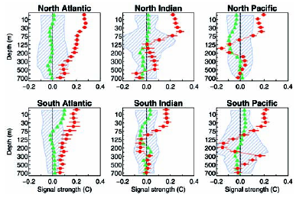
Figure 3: Change of temperature with depth, observations in red dots and PCM results for natural variations with the gray area representing the 90% confidence level of the model results. Model results for solar and volcanic forcing given in green triangles (Barnett et al., 2005).

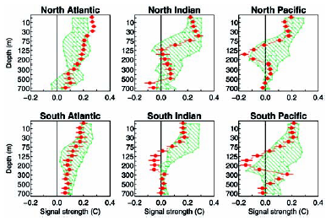
Figure 4: Change of temperature with depth, observations in red dots and PCM results for anthropogenic forcing given in the light green dots with the gray area representing the 90% confidence level of the model results (Barnett et al., 2005).

Barnett et al. conclude that there is a distinct anthropogenic source to the ocean warming signal, as well as natural variability and variability induced by external forcing.
Analysis of the model results shows that the southern oceans are absorbing more energy per unit area than the northern oceans. The authors attribute this to the smaller concentration of aerosols over the southern oceans, a distribution that is partially controlled by the distribution of human industry and population. Their model results show little sensitivity to the details of atmospheric forcing and climate feedbacks, indicating a robust model result within the large 90% confidence range specified. Although the error in model results appears to be very large, the results undeniably pattern the observed temperature signals. The fact that the authors obtain similarly good fits for all six ocean basins lends the reader confidence in the PCM’s ability to predict reality. As well, a second model was used to test the results of the anthropogenic forcing hypothesis and its results were startlingly similar to the PCM results.
The Barnett et al. paper convincingly shows that there is a significant amount of warming in the oceans attributed to anthropogenic forcing. Although their methods are not adequately expounded within the paper, their conclusions and line of logic seem sound. They prove Hansen’s (2005) supposition that the oceans are a major player in absorbing the Earth’s energy surplus. The other question resulting from Hansen’s article can now be considered: does the Antarctic Ice Sheet respond to forcing from the ocean and, if so, on what time scale?

3.2 Instability of the West Antarctic Ice Sheet
A review paper published in 1998 by Michael Oppenheimer gives a comprehensive and critical survey of thinking about the West Antarctic Ice Sheet (WAIS). The WAIS is the smaller portion of the Antarctic Ice Sheet (Figure 4) that is grounded well below sea level, often referred to as a marine ice sheet for this reason. This is the section of the Antarctic ice sheet that has collapsed in the past and is most susceptible to climate variability. Oppenheimer presents a concise, schematic cross-section of ice sheet features relevant to the following discussion, which is reproduced here (Figure 5). Although the ice thicknesses generalized in the diagram are not completely accurate (the
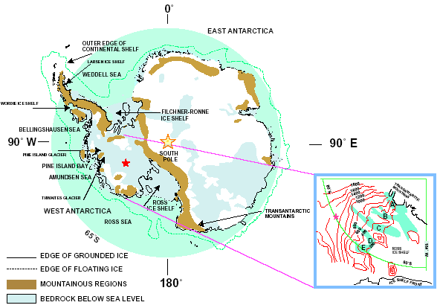
Figure 4: Location map for Antarctica including labels for major features of the continent and oceans. Inset: The Ross Sea Embayment including the Siple Coast ice streams and ice surface elevation contours, fast-flown regions in blue (Oppenheimer, 1998)

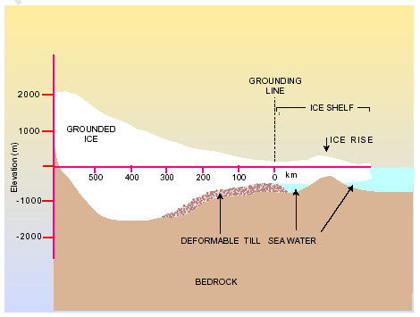
Figure 5: Schematic cross-section of relevant West Antarctic ice sheet features, labeled as necessary (Oppenheimer, 1998).
internal WAIS ice can be up to 3.5km thick), the diagram is a very good representation of the ice sheet grounding line and general morphology of the bed.
Oppenheimer (1998) provides an extensive background section on the WAIS, as is necessary for a review paper published in a comprehensive science journal such as Nature. In the course of this section, he builds the case that the WAIS is not only susceptible to oceanic forcing and human-related forcing but that it is an important, yet neglected, part of climate change in the near future. Oppenheimer identifies the areas of fast flow in Antarctica, including the Siple Coast and Weddell Sea ice streams, as well as the Amundsen Sea Embayment and Antarctic Peninsula glaciers and ice shelves. He appropriately concludes that an significant increase in the net ice flux relative to the ice sheet grounding line (i.e. increased ice discharge from the internal, grounded, portion of the ice sheet) is the only thing that could substantially increase sea level.
Some scientists have hypothesized that ice shelves act to buffer the internal ice from the ocean. Oppenheimer points out that (at this time in 1998) the Larsen and Wordie ice shelves in the Antarctic Peninsula were disintegrating quickly but that the ice behind the Wordie showed no signs of acceleration. He then, correctly, surmised that the situation of the Wordie, where the grounded ice behind the ice shelf is above sea level, does not apply to the rest of West Antarctica where the ice is grounded below sea level. As well, the Larsen and Wordie had a mean annual air temperature of
–5ºC with a summer temperature near the melting point of 0ºC; the rest of the West Antarctic ice shelves were at a mean annual temperature of –15ºC to –25ºC with a summer temperature of –8ºC. Oppenheimer concludes that either the summer air temperature in Antarctica needs to rise by 8ºC to greatly affect the internal ice or some other method of warming would have to be the reason for widespread melting. Oppenheimer hypothesizes that the ice shelves are undergoing melting at their bases and that this melting could trigger acceleration in the ice behind the shelf, a contested view at the time.
Oppenheimer then goes into a review of current models for determining the stability of ice near the coasts. The section describes the pros and cons of each model and ultimately decides that none do an adequate job of describing reality, though some are more accurate than others. Model inadequacy results in an uncertainty in the time scales of ice response. However, it is still clear that the ice must be experiencing forcing by the climate and ocean on all timescales. Of course, that means that the WAIS must always be readjusting and never quite in equilibrium. Oppenheimer does not believe that this could be true and he states, “The early idea that WAIS is subject to hydrostatic instability and rapid grounding-line retreat seems unlikely…”. In fact, since 1997, scientists have proven that rapid grounding-line retreat is a reality and that gives strength to Oppenheimer’s discarded hypotheses.
Oppenheimer then tackles the issue of the rates and magnitudes of discharge needed to produce a significant sea level rise. The IPCC 1995 report concluded that the WAIS would produce a slight drop in sea level over time due to increased accumulation. However, Oppenheimer states that recent measurements (he does not elaborate on what measurements) show high melt rates that far exceed accumulation rates in West Antarctica, especially for Pine Island Glacier in the Amundsen Sea Embayment. Mass balance measurements indicated a –210 Gt/year to –280 Gt/year mass change, indicating a 0.6-0.8 mm/year sea level rise currently attributed to WAIS. The WAIS discharge rate would need to be 6 times greater than that to change IPCC estimates of sea level rise by 2100. Oppenheimer suggests that the collapse of the ice sheet over a period of 500 years could yield the 30-50cm of sea level rise per century needed to dramatically raise sea level by 2100. The estimate for collapse would have to include additional anthropogenic forcing of WAIS melting.
Oppenheimer then looks to the coastal areas of the WAIS. He notes that the Antarctic Peninsula warmed 2.5ºC from 1947 to 1990, though the pattern of warming and cooling over the rest of WAIS is very heterogeneous. If greenhouse gas emissions follow the patterns found in the 1995 IPCC report, then a warming in the oceans of up to 3ºC at depth may be experienced by 2200. Other models also conclude that an increase in accumulation rate will lead to ocean warming at depth. Oppenheimer then eloquently relates the potential impacts of such a warming on the vulnerable ice shelves and glaciers of the Amundsen Sea Embayment.
Finally, Oppenheimer condenses his previous conclusions into three possible WAIS scenarios for policymakers. The first scenario allows basal melt rates to increase, ice shelves to start disintegrating, and internal ice to increase in discharge rate. This produces the collapse of the WAIS within 500-700 years and a WAIS sea level contribution of ~60-120cm per century. The second scenario assumes that ice streams slow with increasing accumulation and that the Antarctic contribution to sea level becomes increasingly negative over time until an 8ºC air temperature warming induces melt in the far future. The third, and final, scenario assumes hydrostatic control of ice discharge and the WAIS would collapse 50-200 years after the ice shelves are removed, which would first take ~200 years. The sea level rise for this scenario would be very rapid but delayed until the ice shelves are removed ~200 years from today. Oppenheimer concludes by saying that the thermal inertia of the ocean and the long residence time of some greenhouse gases in the atmosphere may have already set one of these scenarios in motion and that if our 21st century greenhouse gas emissions follow the IPCC scenarios, substantial WAIS thinning is certain.

3.4 Effect of Ocean Temperatures on the West Antarctic Ice Sheet
Oppenheimer’s 1998 review paper adequately set the stage for the more recent mounting evidence of rapid ice sheet response to climate change, particularly to ocean forcing. A pair of papers published in 2004 illustrates the effects of ocean forcing on the glaciers of the Amundsen Sea Embayment. The first, Payne et al., contends that a tight coupling between the ocean and ice sheet interior is evidenced by the distance inland that the ice sheet responds to changes near the coast and the speed at which this response occurs.
Payne, et al. state that >90% of the ice lost by WAIS discharges through ~10 ice streams and glaciers, of which >40% is drained by the Amundsen Sea Embayment (ASE) glaciers: Pine Island (PIG) and Thwaites (TG). Previous studies has identified the ASE as a potential source of rapid grounding line retreat due to the embayment’s lack of protective ice shelves and drastic deepening of bedrock topography just inland of the current grounding line. Results presented by Payne, et al. show that PIG is currently thinning by 3.5±0.9 m/yr, the grounding line is retreating at 1.2±0.3 km/yr, and that the thinning extends over 200km inland with an average inland thinning rate of 0.75±.07 m/yr. Two of the other glaciers in ASE are also thinning rapidly: TG and Smith glacier (SG). PIG has also shown a 22% acceleration in thinning since 1974.
The Siple Coast ice streams are controlled by the morphology and temperature of the bedrock-ice interface and similar constraints may be affecting the ASE glaciers, but Payne et al. believe that another mechanism is needed to explain the simultaneous thinning experienced by glaciers in the region. The rate of thinning is too high to be related to forcing from the last glacial maximum. Based on the force balance, a change in lateral drag or basal drag could result in the thinning observed. Satellite imagery has shows that there has been no change in the lateral extent of the glaciers, so lateral drag changes cannot be the force responsible. However, change in the basal drag of the glacier’s small ice shelf or its ice plain (the 10km wide zone associated with the grounding line) due to melting could be sufficient to explain the observed thinning.
Payne et al. employ a model of the glacier’s flow to test the above hypothesis. The model makes no assumptions in the ice flow equations about the mechanisms responsible for flow and divides the glacier up into sections to model. The authors assume a linear ice temperature profile with depth from air temperature of the surface to pressure melting point at the bed, which I believe is circumspect. They tune the model to fit the current ice velocities then they allow the model to evolve over time, including vertical changes in ice thickness (Figure 6).
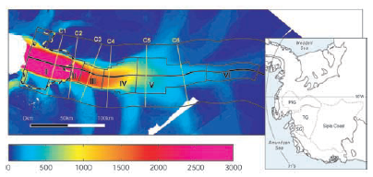
Figure 6: Tuning of the PIG model to fit interferometry measurements of ice velocity in the trunk of PIG. Colors: Interferometry velocities (m/yr) & inset of location with respect to major WAIS drainage basins. (Payne et al., 2004)

The results show that the stress regime of PIG’s trunk is similar to that of the Siple Coast ice streams and implies a similar low strength layer of sediments at the glacier’s base. The steepening (a region 40km upstream from the ice plain) overlies a stronger substrate, probably bedrock or over-consolidated sediments. A change in the model’s basal drag coefficient for the inland ice or changes in the rheology and geometry of the ice shelf can both produce the observed glacier thinning. An instantaneous forcing causes a PIG response and then a return to equilibrium ~150 years later, but in reality the force would be constant, possibly even accelerating, over time and the response of PIG would be much greater. The thinning of PIG is also accompanied by a thickening of the model’s ice shelf, which is not observed in reality and may be due to lack of ocean parameterization in the model.
The results of their modeling show that changes in the ocean dynamics near the mouth of PIG lead to changes in the ice shelf and/or ice plain that propagate inland rapidly, within ~20 years. The authors conclude that the inland ice of WAIS is inextricably tied to the vulnerable coastal areas. Oppenheimer’s incredulity of the possibility of such fast changes is proven incorrect by the observations and modeling of PIG and supported by the work of another paper, Shepherd et al. (2004), on the thinning observed in the small ice shelves of the ASE glaciers.
The PIG ice shelf has thinned by 5.5 m/yr over the last 10 years and is mirrored by thinning of the ASE glaciers, for all of which ocean temperatures of 0.5°C above freezing are to blame. The ASE glaciers are responsible for 0.13±0.02 mm/yr of sea level rise by themselves. ERS altimetry has been collected every 35 days (with a 10km footprint and spacing between repeat ground tracks of 19km) for the last 9 years. This data shows that the small ice shelves in the ASE have lowered in elevation up to 59±6 cm/year. THW and PIG are the highest rates, with decreasing rates for glaciers to the west and east. This represents a 10-fold reduction in ice mass either from decreased glacier influx (which we know to actually be increasing) or increasing ice shelf basal melting. A plot of ocean temperature from a 1997 cruise in the ASE versus melt rate shows a startling, and telling, positive correlation (Figure 7). Downstream from the ASE coast, the waters in the Ross Sea have freshened ~46 Gt/yr over the past 40 years, which can be explained by the release of fresh water from the ASE ice shelves.
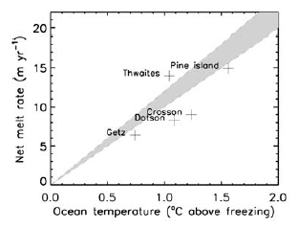
Figure 7: Net melt rate of ASE ice shelves versus ocean temperature from a 1997 cruise in the ASE (Shepherd et al., 2004).

4. Conclusions
It is obvious from the discussion in the literature that despite some controversy over historical temperature curves (McKitrick, 2003), there exists other compelling evidence of anthropogenic forcing of global warming. The evidence presented from the ocean temperatures (Barnett et al., 2005) shows that the oceans will become a major player in future climate change. Discussions by Hansen (2005) and Oppenheimer (1998) then illustrate the possible impacts of anthropogenic global warming on the West Antarctic Ice Sheet. Data and models (Payne et al., 2004; Shepherd et al., 2004) have shown that oceanic forcing of the coastal areas of the WAIS has a profound impact on the inland ice.
Together, these papers present a bleak outlook on the future of the WAIS. Continued anthropogenic forcing (which society shows little interest in curbing) will exacerbate the current planetary energy imbalance, further warming the oceans, and accelerating the discharge of the WAIS, possibly to the point of collapse in the near future. Oppenheimer’s scenario number one, involving the most immediate and extreme response of WAIS and consequent sea level rise of 60-120 cm this century, appears to be closer to reality than previously expected. Scientists need to continue to monitor the oceans and greenhouse gas emissions while also improving their models of the WAIS to allow for realistic boundary conditions. Society as a whole should pause and take stock of the possibility that their actions could dramatically affect the lives of future generations and weigh the costs of environmental responsibility now versus dramatic sea level rise in the future.

5. References

Barnett, T.P., D.W. Pierce, K.M. AchutaRao, P.J. Gleckler, B.D. Santer, J.M. Gregory, and W.M. Washington. 2005. "Penetration of Human-Induced Warming into the World's Oceans." Science, 309(5732), 284-287.
Hansen, J.E. 2005. "A Slippery Slope: How Much Global Warming Constitutes "Dangerous Anthropogenic Interference" ?" Climatic Change, 68, 269-279.
McKitrick, R. 2003. "What Is the 'Hockey Stick' Debate About?" In: APEC Study Group, Australia, 1-18.
Oppenheimer, M. 1998. "Global Warming and the Stability of the West Antarctic Ice Sheet." Nature, 393, 325-332.
Payne, A.J., A. Vieli, A. Shepherd, D.J. Wingham, and E. Rignot. 2004. "Recent Dramatic Thinning of Largest West Antarctic Ice Stream Triggered by Oceans." Geophysical Research Letters, 31.
Shepherd, A., D.J. Wingham, and E. Rignot. 2004. "Warm Ocean Is Eroding West Antarctic Ice Sheet." Geophysical Research Letters, 31, 1-4.

